CrazyCholeBlack
- Scourge o' the 7 Seas
- 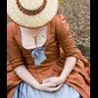
- Member

- 1,578 posts
- Gender:Female
- Location:Illinois
- Interests:Everything! Historic clothing, sewing, fabric dying, cooking, mead, ale, astronomy, celestial navigation, reading, music, film making, blogging & pillaging the internet for visual inspirations.
Posted September 13, 2006 · Report post
I know that eye glasses were invented well before the GAoP yet I don't seem to find many references to them during the period. I also can't recall seeing any images with someone wearing or even holding them. I am hoping that some of the more studious might be able to assist me in this tidbit of research.

Capn_Enigma
- Plunderer
- Member

- 432 posts
Posted September 13, 2006 · Report post
While they are no period depictions, here are some examples of spectacles from the 16th century, and a pair of glasses from the 17th century
I even found the ladies version of spectacles which was fixed to the hood of this charming lady.
Compared to these glasses, the Clark Kent model are really cool shades.

Gentleman of Fortune
- Dread Pyrate
- Member

- 1,456 posts
- Gender:Male
- Location:Germany... Franconia (northern Bavaria)
- Interests:I *used* to be an environmental scientist, until I married a DoDDs teacher in 1997. Since then, I have been living in, and traveling around, Europe (First the UK, now Germany).
My hobbies are all the "usual suspects" for those interested in re-enacting and Golden Age of Piracy stuff.... but I have drifted away from the pirate scene as my location and young family don't allow for any more than "virtual" pirate participation. Besides Piracy, I am into Reverend Guitars and Vintage Corvettes.
Posted September 13, 2006 · Report post
Glasses (with side ear pieces) like modern glasses come in just after the GAoP. If you google "glasses history" you will get a lot of links and see lots of examples.
The "period" glasses sold by most vendors are F&I or Rev War period.
Greg

Capt. Sterling
- Sticky Fingers Sterling Needs a New Hat
- Member

- 10,302 posts
- Gender:Pyrate Hunter
- Location:here
- Interests:Killing pirates, haven't met one yet worth keeping alive....
Posted September 13, 2006 · Report post
There were quizzing lenses already as well...
http://www.eyeglasseswarehouse.com/quizzing.html
supposedly the first two are late 17th century
Here's some brief info
http://www.college-optometrists.org/index....cles.seventeen/

jessie k.
- Ship's Master
- Member

- 180 posts
- Location:Midwestern US
- Interests:Oh, everything. :D But to list a few...pirates, medieval history, horses, plants and their practical uses, books (all of them), archaeology, people, canoeing, camping, FIRE, etc.
Posted September 19, 2006 · Report post
The version without ear pieces; were they held up to the face, or did they pinch onto the nose?

Capt. Sterling
- Sticky Fingers Sterling Needs a New Hat
- Member

- 10,302 posts
- Gender:Pyrate Hunter
- Location:here
- Interests:Killing pirates, haven't met one yet worth keeping alive....
Posted September 19, 2006 · Report post
jessie k. said:
The version without ear pieces; were they held up to the face, or did they pinch onto the nose?
Earlier on they were held in place, but supposedly by the beginning of the GAoP they were already pinching the nose...

Brit.Privateer
- Old Twillian
- Member

- 246 posts
- Gender:Male
- Location:North Carolina
- Interests:Atlantic World Maritime History during the Colonial Era. I specialize in early provincial era (1680-1740) and do quite a bit with pirate history.
Posted September 20, 2006 · Report post
Here is another question that may influence the whole thing on glasses, were there a significant number of people who needed glasses back then? I would imagine if the demand for glasses were low, that little effort would be put toward developing a functional pair for the public. Also, if knowledge of the amount of people who needed glasses is known, do we know if they are far sited or near sighted. If the majority of those needing glasses were near sited (meaning they can not see things close up), I would have a feeling that many would not want or try to get glasses (I have seen many people at convenience stores who have problems reading the credit card swiper screen being able to write their check, due to "they forgot their glasses." If people today don't see glasses as important enough to have with them everywhere, then I can imagine common people back then not even thinking of getting glasses due to they thought they would not be that important. Many people wouldn't need them due to they couldn't read and write.). That is a angle to look at it from.

CrazyCholeBlack
- Scourge o' the 7 Seas
- Member

- 1,578 posts
- Gender:Female
- Location:Illinois
- Interests:Everything! Historic clothing, sewing, fabric dying, cooking, mead, ale, astronomy, celestial navigation, reading, music, film making, blogging & pillaging the internet for visual inspirations.
Posted September 21, 2006 · Report post
that is an interesting way to think about eye glasses. It was definately a less "reading heavy" lifestyle. I can see that there would be less need for close vision problems. Though there would still be people such as myself who can't see past arms length & wouldn't be functional without some sort of eye assistance. There is always the issue of cost. Eye glasses didn't get common until there was a way to mass produce lenses (1800 something right?)
It's an interesting detail to think about.

jessie k.
- Ship's Master
- Member

- 180 posts
- Location:Midwestern US
- Interests:Oh, everything. :D But to list a few...pirates, medieval history, horses, plants and their practical uses, books (all of them), archaeology, people, canoeing, camping, FIRE, etc.
Posted September 21, 2006 · Report post
Maybe they were simply too expensive for most people? I know I, personally, would not be able to see much farther than my nose without glasses or contact lenses. And while reading may not have been an issue, things like sewing would have been troublesome without glasses.

Red Maria
- Dread Pyrate
- Member

- 1,057 posts
Posted September 21, 2006 · Report post
At a Anitquarian book faire I work at back in Febuarary the booth across from us had besides books various optics among which were a sample case of glass eyes and two pairs of period eyeglasses. One was 16thc. the other 18thc. the 16thc. werr hand held the 18thc. had ear peices. I do recall an 16thc. portrait of a cardinal wearing eyeglasses with ear pieces.
Personally if I don't wear my glasses I get teribble headaches. I try to wear as period eyeglasses that my perscription will allow.

Gentleman of Fortune
- Dread Pyrate
- Member

- 1,456 posts
- Gender:Male
- Location:Germany... Franconia (northern Bavaria)
- Interests:I *used* to be an environmental scientist, until I married a DoDDs teacher in 1997. Since then, I have been living in, and traveling around, Europe (First the UK, now Germany).
My hobbies are all the "usual suspects" for those interested in re-enacting and Golden Age of Piracy stuff.... but I have drifted away from the pirate scene as my location and young family don't allow for any more than "virtual" pirate participation. Besides Piracy, I am into Reverend Guitars and Vintage Corvettes.
Posted September 21, 2006 · Report post
Well, i don't know....
According to Antique Spectacles the first side arm temple glasses don't come about till 1726ish
Quote
From the beginning, spectacles failed to remain in position and stay on. As noted during the 15th and 16th centuries, they were of the riveted type which was normally hand-held. These spectacles evolved into the type with a more comfortable arched bridge known as bow specs. Following this, the ultra-rare slit-bridge spectacles appeared with slits to give some added elasticity to the nose bridge. Then one piece wire (usually copper) frames with round lenses, better known as Nuremberg style nose spectacles, came into fashion, being mass-produced throughout the 17th century and until the early 19th century. Compounding the problem of stability, the first spectacles did not have side arms. This critical problem went unsolved for about 440 years until finally London optician Edward Scarlett (1677-1743) was credited with perfecting temple spectacles – those having short, stiff side pieces ending in a circular ring that pressed against the temples above the ears. This innovation facilitated the easy putting on and taking off of the glasses and didn’t interfere with a person’s long hair or wig. It hasn’t been proven that Scarlett truly was the inventor. He advertised spectacles with spiral ends and his trade card is the earliest surviving illustration of them. Twenty-five years later, longer sides (temples) hinged in the middle became popular. This change finally added much needed comfort and stability. Another London instrument-maker and optician, James Ayscough, gets the credit for inventing this first double-hinged temple in 1752. He described these sides as "so contrived as to press neither upon the nose nor upon the temples."
GoF

blackjohn
- Iron Age Hero Lost at Sea
- 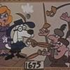
- Member

- 3,745 posts
- Gender:Male
- Location:Columbia, Md
- Interests:Stuff... and junk.
Posted September 22, 2006 · Report post
This pic is spot on GAP.

Mission
- Goat Specialist
- Admin

- 5,081 posts
- Gender:Male
- Location:Monroe, MI
- Interests:Scholarly piracy, designing and creating haunted house rooms and props, movies, abstract thinking, abstruse thinking, obstructive thinking, ideating, random thinking, movies, cartoons, movies, movies scores, cycling, world peace and small furry dogs, movies, writing, drawing, personal skills training, gremlins and, of course, lest I forget, movies.
Posted May 11, 2009 · Report post
I found this in Elizabeth Bennion's, Antique Medical Instruments:
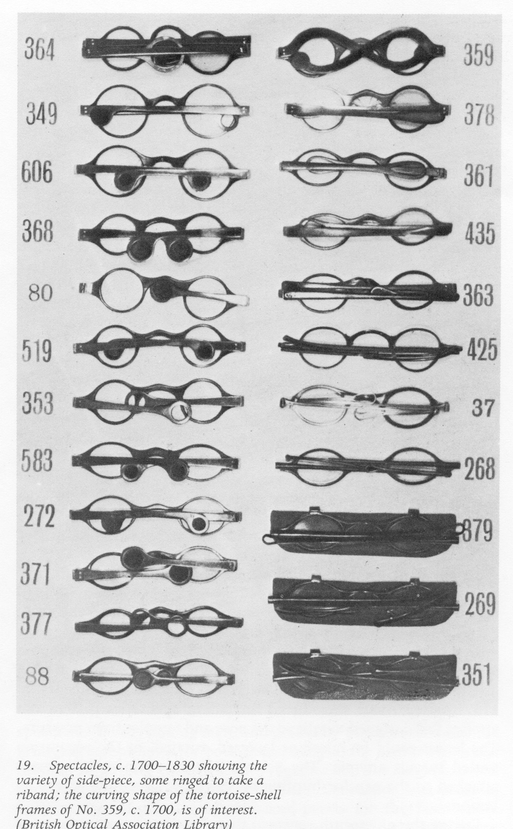
This suggests that eyeglasses with some way to attach them to the wearer's head existed in 1700. (Quick, someone over there go check the British Optical Ass'n Library for verification.) I do wish we knew the dates of each of those.
Also, according to Bennion, eye glasses and pince nez glasses were very popular and common and could be fairly cheaply purchased.
"In the late fifteenth century they [glasses] were occasionally held on by an extension over the forehead. Early frames were made of brass or iron and then of horn, bone, gold, silver and even of leather. The first lenses were only for long-sightedness and were ground from berillus or beryl, a smoke coloured glass. From beryl came the French bericle and later besicles, meaning spectacles. The word 'lenses' comes from the Italian word for lentils. Eye-glasses, being precious, required cases, and these were often the most intricate and beautiful works of art, made of wood, metal, or ivory or, for the hoi polloi, leather, horn or parchment. Sometimes, since spectacles were only
__
__
used for reading, the case was contrived in the cover of a book. With the invention of the printing press in 1476 more and more people wished to read, resulting in large scale production for the spectacle-maker. Prices fell and spectacles were sold by pedlars; glasses were available to almost all. The first known spectacle-maker was one in Nuremberg in 1478 and by 1567 that city had entirely regularised the craft.
The sixteenth-century saw the introduction of concave lenses for the short-sighted, and the innovation of oval lenses meant that one might look over them for distance vision. Frames were becoming slightly more flexible; some were strapped round the head with leather, others had cord around each ear, and others still were attached to a hat. A book entitled A Briefe Treatise touching the Preservation of the Eisight, published in 1586, mentions the usefulness of tinted glasses, and by 1591 lenses of amber, soaked in linseed oil, were used as protection against the sun." (Bennion, p. 233-5)
"The seventeenth century saw a return to the single eye-glass, mostly for the rich who did not wish to be associated with double ones now that they had become available to all." (Bennion, p. 237)
"The form of mid-seventeenth-century spectacles is not clear as the books of the London Spectacle Makers' Company were burned in the Great Fire, but by the end of the century we read of black frames for sale at 5d the pair and ordinary
__
white ones for 7d. Samuel Pepys, whose bad eyesight regrettably caused him eventually to stop writing his diary, nevertheless in 1666, 'did this evening buy me a pair of green spectacles to see whether they will help my eyes or no.'" (Bennion, p. 237-8)

Joe Pyrat
- Plunderer
- Member

- 395 posts
- Location:Sailing down the east coast
- Interests:Sailing, History, specifically 1670 - 1725, all manner of muzzle loading weapons, good food, good music and good rum, aye, good rum...
Posted May 11, 2009 · Report post
My thought on whether or not to wear glasses is that most common citizens would not be able to afford them so I don't wear them (my long range glasses). I can see well enough that this isn't a problem so I carry my reading glasses in my pocket for those moments when they are needed. If your vision requires them then wear them (even if you don't have PC frames) as safety trumps PC every time. This, of course, depends on who you are protraying. If it's some lord or other welthy individual then they would be appropriate.

Mission
- Goat Specialist
- Admin

- 5,081 posts
- Gender:Male
- Location:Monroe, MI
- Interests:Scholarly piracy, designing and creating haunted house rooms and props, movies, abstract thinking, abstruse thinking, obstructive thinking, ideating, random thinking, movies, cartoons, movies, movies scores, cycling, world peace and small furry dogs, movies, writing, drawing, personal skills training, gremlins and, of course, lest I forget, movies.
Posted May 11, 2009 · Report post
Joe Pyrat said:
My thought on whether or not to wear glasses is that most common citizens would not be able to afford them so I don't wear them (my long range glasses). I can see well enough that this isn't a problem so I carry my reading glasses in my pocket for those moments when they are needed. If your vision requires them then wear them (even if you don't have PC frames) as safety trumps PC every time. This, of course, depends on who you are protraying. If it's some lord or other welthy individual then they would be appropriate.
Actually, if you read those last few quotes, eyeglasses in one form or another were available to one and all. However, I can see the argument for wearing your regular glasses if that's what it takes for you to function, especially if you can't wear contacts. Dead Eye with the Bone Island Buccaneers informed me that his vision is so bad without glasses that they won't issue him a driver's license. Looking period is important, but you there's no sense in being a damned fool about it.

Joe Pyrat
- Plunderer
- Member

- 395 posts
- Location:Sailing down the east coast
- Interests:Sailing, History, specifically 1670 - 1725, all manner of muzzle loading weapons, good food, good music and good rum, aye, good rum...
Posted May 11, 2009 · Report post
My point was not reference availability, but about affordability. What was the cost glasses at the time? Since the lenses could not be mass produces I would guess the cost was substantial and unless a person could just not function without them they would make due and not spend the money. Pirates, of course, have the ability to bypass such economic issues. :)

Sjöröveren
- Plunderer
- Member

- 457 posts
- Location:Minnesota, Land of 10,000 Lakes and 1 mini-ocean
- Interests:Re-enactment, gradually working my way back from the 19th Century. I figure I'm in about 1700 right now. I specialize in the history of medicine. I like maps, and the general history of geography and geodesy. <br />And in case you're wondering, "Sjöröveren" is Swedish for "the sea rover." And it's supposed to be spelled "Sjörövaren" but I guess it's too late for that!
Posted May 11, 2009 · Report post
blackjohn said:
This pic is spot on GAP.
This picture is great! It means that I can wear my "period" glasses for distance, and my pince nez for reading. I had always thought that pince nez were 19th century at the earliest.

Mission
- Goat Specialist
- Admin

- 5,081 posts
- Gender:Male
- Location:Monroe, MI
- Interests:Scholarly piracy, designing and creating haunted house rooms and props, movies, abstract thinking, abstruse thinking, obstructive thinking, ideating, random thinking, movies, cartoons, movies, movies scores, cycling, world peace and small furry dogs, movies, writing, drawing, personal skills training, gremlins and, of course, lest I forget, movies.
Posted May 11, 2009 · Report post
Joe Pyrat said:
My point was not reference availability, but about affordability. What was the cost glasses at the time? Since the lenses could not be mass produces I would guess the cost was substantial and unless a person could just not function without them they would make due and not spend the money. Pirates, of course, have the ability to bypass such economic issues. :)
Going by this quote:
"The seventeenth century saw a return to the single eye-glass, mostly for the rich who did not wish to be associated with double ones now that they had become available to all.” (Bennion, p. 237)
and this one:
"With the invention of the printing press in 1476 more and more people wished to read, resulting in large scale production for the spectacle-maker. Prices fell and spectacles were sold by pedlars; glasses were available to almost all. The first known spectacle-maker was one in Nuremberg in 1478 and by 1567 that city had entirely regularised the craft." (Bennion, p. 235)
Extrapolating from the late 15th century forward, my guess is that they were produced in larger quantities during period and available from street peddlers in various standard strengths - kind of like reading glasses are today at K-Mart. The street peddler sold primarily to the common people as I understand it.

Joe Pyrat
- Plunderer
- Member

- 395 posts
- Location:Sailing down the east coast
- Interests:Sailing, History, specifically 1670 - 1725, all manner of muzzle loading weapons, good food, good music and good rum, aye, good rum...
Posted May 11, 2009 (edited) · Report post
Interesting, any idea what the percentage of people who could read was, excluding the upper classes? Teach is often mentioned as being unique among pirates in his ability to read and write so it appears that the percentage was not high. It would seem that the merchant class and above may have been more literate then sailors though. What made me wonder regarding the cost was a conversation we had at the Castillo this weekend regarding the making of paper cartridge tubes becoming a cottage industry where the producer was paid only 1 cent per 100. When combined with other sources regarding wages and the practice of often reneging on paying owed wages I was wondering how much of a luxury item these would be among the commoners. However if they were producing them in quantity there must have been a market for them.
Edit...
Oh, BTW Mission, there is a gentleman at the Castillo who is our surgeon and has an extensive collection of medical gear. I mentioned you were also very interested in the period medical arts but we didn't have time to continue our conversation. Would you like me to pass along your email address? PM me if you like.
Edited May 11, 2009 by Joe Pyrat

Mission
- Goat Specialist
- Admin

- 5,081 posts
- Gender:Male
- Location:Monroe, MI
- Interests:Scholarly piracy, designing and creating haunted house rooms and props, movies, abstract thinking, abstruse thinking, obstructive thinking, ideating, random thinking, movies, cartoons, movies, movies scores, cycling, world peace and small furry dogs, movies, writing, drawing, personal skills training, gremlins and, of course, lest I forget, movies.
Posted May 11, 2009 · Report post
Good point. Regular seamen and men pressed into piratical service occasionally kept journals, so we know some of them could write (and, logically, read.) Probably not the majority of them, though. I could see an argument suggesting that most seamen who couldn't read wouldn't even be totally aware that they needed vision correction. (Except the surgeon, the navigator (both of whom could most likely read) and the sailmakers. Maybe the carpenter.)

Capt. Sterling
- Sticky Fingers Sterling Needs a New Hat
- Member

- 10,302 posts
- Gender:Pyrate Hunter
- Location:here
- Interests:Killing pirates, haven't met one yet worth keeping alive....
Posted May 11, 2009 · Report post
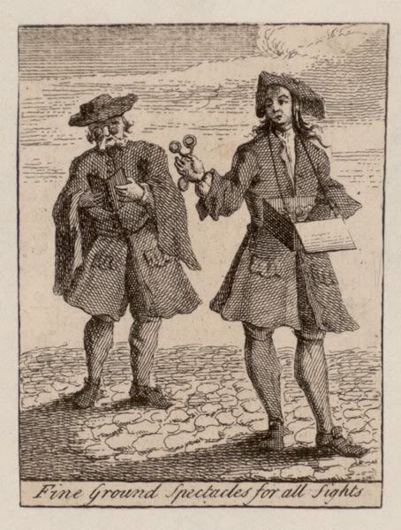
More spectacles without side pieces.

Captain_MacNamara
- Plunderer
- Member

- 467 posts
- Gender:Male
- Location:The Seas of Ansteorra
- Interests:Piracy, the Sea, Sailing Vessels, Period Gunnery, and Rum...
Posted May 11, 2009 · Report post
Aye... I've tried to wear a pair similar to those, and they hurt my nose. I try to go without my specs at events, even though it's just the SCA... but I have astigmatism, and for some reason get really nasty headaches if I go too long without them. I thought about getting a pair of these, as they look ok and are "period", just not the right period... but still closer to period than my modern frames:
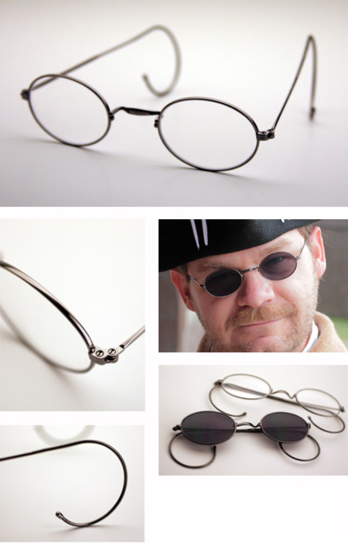

Sjöröveren
- Plunderer
- Member

- 457 posts
- Location:Minnesota, Land of 10,000 Lakes and 1 mini-ocean
- Interests:Re-enactment, gradually working my way back from the 19th Century. I figure I'm in about 1700 right now. I specialize in the history of medicine. I like maps, and the general history of geography and geodesy. <br />And in case you're wondering, "Sjöröveren" is Swedish for "the sea rover." And it's supposed to be spelled "Sjörövaren" but I guess it's too late for that!
Posted May 12, 2009 (edited) · Report post
Captain_MacNamara said:
Aye... I've tried to wear a pair similar to those, and they hurt my nose. I try to go without my specs at events, even though it's just the SCA... but I have astigmatism, and for some reason get really nasty headaches if I go too long without them. I thought about getting a pair of these, as they look ok and are "period", just not the right period... but still closer to period than my modern frames:
I used to have a pair just like these, and I wouldn't get another like them. They were very tight behind the ears, even after loosening the coil of the loops. They also corroded from perspiration very quickly. The place where the nosepiece joined the lens frame turned green and corroded in two within a year.
Edited May 12, 2009 by Sjöröveren

Mission
- Goat Specialist
- Admin

- 5,081 posts
- Gender:Male
- Location:Monroe, MI
- Interests:Scholarly piracy, designing and creating haunted house rooms and props, movies, abstract thinking, abstruse thinking, obstructive thinking, ideating, random thinking, movies, cartoons, movies, movies scores, cycling, world peace and small furry dogs, movies, writing, drawing, personal skills training, gremlins and, of course, lest I forget, movies.
Posted September 11, 2011 · Report post
I found what appears to be a period reference in the book The Travels of Monsieur de Thevenot into the Levant in Three Parts,
"There is no Winter on this Island [Malta], nor no need of warming one's self by the fire; on the contrary, they always drink their Wine with Ice. [This is not relevant, but I do wonder where they got the ice.] The Air is very thin and wholsom for Old Men, who can hardly die; but Head-aches are dangerous there, and sore Eyes, because of the whiteness of the Earth, which makes many Commanders and Knights to wear green Spectacles, though I cannot tell but that the Glass by contracting the beams of the Sun, may burn their Eyes." (Thevenot, p. 6)

jendobyns
- Pyrate Captain
- Member

- 562 posts
- Gender:Female
- Location:Baltimore
- Interests:too numerous to mention, really. Period foodways, baroque dance, material culture, etc., etc.
Posted September 11, 2011 · Report post
Mission, that is just wonderful! Do you have a date for the work? I can't tell you how many people have got it into their heads that dark lenses were to protect the eyes of people suffering from venereal disease! In spite of research done over a decade ago proving that is just not so. Sigh

Mission
- Goat Specialist
- Admin

- 5,081 posts
- Gender:Male
- Location:Monroe, MI
- Interests:Scholarly piracy, designing and creating haunted house rooms and props, movies, abstract thinking, abstruse thinking, obstructive thinking, ideating, random thinking, movies, cartoons, movies, movies scores, cycling, world peace and small furry dogs, movies, writing, drawing, personal skills training, gremlins and, of course, lest I forget, movies.
Posted September 12, 2011 · Report post
I believe that particular part was written in the early 1650s.
Here's the Wiki bio on Jean de Thevenot.
While it affirms the use of sunglasses, there are a couple of things to take into consideration: 1) It refers specifically to Malta, which may mean it was not geographically widespread. 2) He also attributes the behavior to "Commanders and Knights" and not common folk, and 3) He casts aspersions on the behavior, believing it may do the opposite of what's intended.
Say, does someone have a reference for this Syphilis/tinted glasses thing? I have read at least twenty period books on medicine and a dozen or more period sailors accounts and never yet come across a reference to this.

jendobyns
- Pyrate Captain
- Member

- 562 posts
- Gender:Female
- Location:Baltimore
- Interests:too numerous to mention, really. Period foodways, baroque dance, material culture, etc., etc.
Posted September 12, 2011 · Report post
Thanks for the info on Thevenot.
I can't tell you the original sources regarding the colored lenses and different diseases, but iirc that research, which is OOP for this forum, was "published" on the Revlist (yahoo group) over a decade ago (between 10 and 13 years?). I have, since then, seen accounts that back up the "sunglasses" part, but since the disease part beyond migraines didn't interest me, I didn't take notes. Sorry. There are newspaper advertisements for glasses of various types in the newspapers of the time, too. If you have access to the PA Gazette, it could be a starting point. As would the Revlist group.
There was a wonderful pair of tortoise shell spectacles with dark green lenses on display at the Smithsonian years ago. They (the Smithsonian) might also have information for you.
Good luck!
Jen
On 9/12/2011 at 8:10 AM, Mission said:
I believe that particular part was written in the early 1650s.
Here's the Wiki bio on Jean de Thevenot.
While it affirms the use of sunglasses, there are a couple of things to take into consideration: 1) It refers specifically to Malta, which may mean it was not geographically widespread. 2) He also attributes the behavior to "Commanders and Knights" and not common folk, and 3) He casts aspersions on the behavior, believing it may do the opposite of what's intended.
Say, does someone have a reference for this Syphilis/tinted glasses thing? I have read at least twenty period books on medicine and a dozen or more period sailors accounts and never yet come across a reference to this.

Grymm
- First Mate
- Member

- 281 posts
- Gender:Male
- Location:Chilterns UK
- Interests:Stuff
Posted September 13, 2011 · Report post
http://www.museumofvision.org/exhibitions/?key=44&subkey=4&relkey=35
There's a wee clicky link on the LH side to take you to the 18thC collection, This one pair is tagged as being 1700
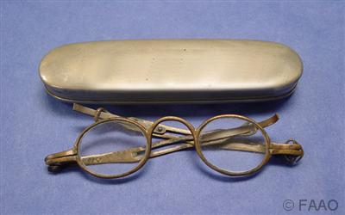
http://www.antiquespectacles.com/ Has some pretties too.
The nose bridge specs can have cords or threads looped over the ears to keep them on, also means that they are much less likely fall off when looking down or when you turn violently.
From the Optometrists College website in the musEYEum section http://www.college-optometrists.org/en/knowledge-centre/museyeum/index.cfm
The writings of de Valdes
In 1623 the Spanish writer B. Daza de Valdes produced a semi-fictional pamphlet with the somewhat lengthy title: Vso de los antojos para todo genero de vistas: en que se ensena a conocer los grados que a cada vno le faltan de su vista, y los que tienen qualesquier antojos. Y assi mismo a que tiempo se an de vsar, y como se pediran en ausencia, con otros auisos importantes, a la vtilidad y conseruacion de la vista. In this work he describes a user of spectacles in Seville, whom he names Marcel, complaining that his leather spectacles were of clumsy manufacture and kept falling off. As a result Marcel aspired to upgrade to a silver pair though, in fact, a well-made leather pair would have stayed on the nose better due to its greater flexibility and lighter weight. A spectacle maker informed Marcel of this; the set-piece conversation, if it can be believed, is interesting evidence of a dialogue between manufacturer and customer. A passing reference is made to looping the spectacles over the ears. This Marcel rejects on account of it looking less smart and being associated with older people. It seems he would rather break more pairs than benefit from the convenience of ear loops; perhaps the spectacle makers were happy to acquiesce in this if it meant a higher demand for new pairs?
From the same site re green tinted specs
Samuel Pepys 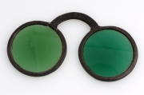
The great diarist Samuel Pepys (1633-1703) purchased a pair of spectacles with green lenses from the respected and 'great' spectacle maker John Turlington in December 1666 in the hope that the tint might relieve the soreness of his eyes caused, so he believed, by labouring under candlelight. They may have looked a little like this pair with a leather frame. Turlington was Master of the Spectacle Makers Company at the time. Dating these spectacles is problematic. Whilst they are perhaps most likely to be from the second half of the century, stylistically they could date from as early as 1600 which would make them the oldest pair in the museum collection.
Pepys was a regular drinking partner of Sir Isaac Newton, who discovered the colour spectrum and may possibly have discussed optics with him. Aids to vision had many uses as one entry from his diary of May 1667 will show: I did entertain myself with my perspective glass up and down the church, by which I had the great pleasure of seeing and gazing a great many very fine women; and what with that and sleeping, I passed away the time till sermon was done.
There is also a section on specs with arms which throws a few early possibles into the mix.

Mission
- Goat Specialist
- Admin

- 5,081 posts
- Gender:Male
- Location:Monroe, MI
- Interests:Scholarly piracy, designing and creating haunted house rooms and props, movies, abstract thinking, abstruse thinking, obstructive thinking, ideating, random thinking, movies, cartoons, movies, movies scores, cycling, world peace and small furry dogs, movies, writing, drawing, personal skills training, gremlins and, of course, lest I forget, movies.
Posted September 13, 2011 · Report post
On 5/11/2009 at 10:05 AM, Mission said:
I found this in Elizabeth Bennion's, Antique Medical Instruments:
This suggests that eyeglasses with some way to attach them to the wearer's head existed in 1700. (Quick, someone over there go check the British Optical Ass'n Library for verification.) I do wish we knew the dates of each of those.
Also, according to Bennion, eye glasses and pince nez glasses were very popular and common and could be fairly cheaply purchased.
My link to the above photo got broken somehow, so I fixed it. Image 359, with sidepieces is dated to 1700 like Grymm's pair. So unless both sources are wrong, they clearly existed at that time.

Mission
- Goat Specialist
- Admin

- 5,081 posts
- Gender:Male
- Location:Monroe, MI
- Interests:Scholarly piracy, designing and creating haunted house rooms and props, movies, abstract thinking, abstruse thinking, obstructive thinking, ideating, random thinking, movies, cartoons, movies, movies scores, cycling, world peace and small furry dogs, movies, writing, drawing, personal skills training, gremlins and, of course, lest I forget, movies.
Posted February 24, 2012 · Report post
On 5/11/2009 at 11:03 AM, Joe Pyrat said:
My thought on whether or not to wear glasses is that most common citizens would not be able to afford them so I don't wear them (my long range glasses).
This is just on of several comments about this question of who would have spectacles during period. I happened to be skimming through the link to the fascinating Museum of Vision provided by Grymm and I noticed this statement:
"By 1700, the middle and lower classes were wearing spectacles mounted in various simple materials, while the upper classes favored more genteel hand held spectacles with frames of gold and silver."

Capt. Sterling
- Sticky Fingers Sterling Needs a New Hat
- Member

- 10,302 posts
- Gender:Pyrate Hunter
- Location:here
- Interests:Killing pirates, haven't met one yet worth keeping alive....
Posted February 24, 2012 · Report post
Wow Mission, if ye could find a primary source for the sidebars that would be grand and very helpful to a lot of folks.

Mission
- Goat Specialist
- Admin

- 5,081 posts
- Gender:Male
- Location:Monroe, MI
- Interests:Scholarly piracy, designing and creating haunted house rooms and props, movies, abstract thinking, abstruse thinking, obstructive thinking, ideating, random thinking, movies, cartoons, movies, movies scores, cycling, world peace and small furry dogs, movies, writing, drawing, personal skills training, gremlins and, of course, lest I forget, movies.
Posted February 24, 2012 · Report post
All I've seen is those glasses from Bennion's book which reference the British Optical Association Library. I've only seen passing references in period sources to glasses and spectacles; nothing that describes the glasses themselves.

Capt. Sterling
- Sticky Fingers Sterling Needs a New Hat
- Member

- 10,302 posts
- Gender:Pyrate Hunter
- Location:here
- Interests:Killing pirates, haven't met one yet worth keeping alive....
Posted February 24, 2012 · Report post
Hmmm Grymm are ye sure about that brass set with the case? I'm reading C. 1830
http://www.museumofvision.org/collection/artifacts?accession=1986.000.00880

Captain Jim
- Captain Jim for Captain!
- Member

- 2,254 posts
- Gender:Male
- Location:Off the coast of Tampa Bay (Unfortunately, inland from the coast)
- Interests:I'm 57, formerly a wildlife ecologist and biologist, now a stay-at-home dad. I grew up on the west coast of Florida, where Anna Maria Sound and Tampa Bay were my playground. My interests include, but are not limited to cannon, black powder arms, history, fishing the flats, sailing, fine wood working, flint gun building, hunting, good gun dogs. Above all, my wife and children.
Posted February 24, 2012 (edited) · Report post
El Greco, 1600. Metal frames, ribbons around ears. From here, did it really take 120 years to put temples on?
Edited February 24, 2012 by Captain Jim

IvanHenry
- Deck Swabber
- Member

- 44 posts
Posted March 22, 2012 · Report post
Nice find!

Jib
- Dread Pyrate
- Member

- 1,076 posts
- Gender:Male
- Location:Minneapolis, MN
- Interests:Piracy, stage combat, martial arts, reading, film, travel
Posted March 22, 2012 · Report post
I was just reading something about Newton and it suggested that he constructed a set of glasses with colored lens to see light break into the spectrum. I believe it was gold colored lens and the wearer saw everything with a blue haze.

landlubbersanonymous
- Plunderer
- Member

- 354 posts
- Gender:Not Telling
- Location:California, USA
- Interests:History, arts, collecting, reenacting
Posted March 22, 2012 (edited) · Report post
Have not done business here but the product looks interesting for a late impression.
http://www.nehelenia...sunglasses.html
and at bottom of page...
http://home.comcast....ge/MainMisc.htm
Was thinking of converting a cheap modern mfg reading set to appear like older pair. I suppose these could be converted as well. (To replicate 17th century round frames sans the arms.) We'll post pics if that comes to fruition.
Edited March 22, 2012 by landlubbersanonymous

Grymm
- First Mate
- Member

- 281 posts
- Gender:Male
- Location:Chilterns UK
- Interests:Stuff
Posted March 24, 2012 (edited) · Report post
On 2/24/2012 at 6:14 PM, Capt. Sterling said:
Hmmm Grymm are ye sure about that brass set with the case? I'm reading C. 1830
http://www.museumofv...=1986.000.00880
Yeah, serves me right for believing one set of blurb and not double checking. I've been doing a bit more swotting up on period specs and the sliding arm is v late 18thC and the oval lenses put them into the 19thC....bugger!
More sites more info
http://www.college-optometrists.org/ go to knowledge centre then musEYEum in the drop down.
http://​www.antiquespectacles.com/
Edited March 24, 2012 by Grymm

Grymm
- First Mate
- Member

- 281 posts
- Gender:Male
- Location:Chilterns UK
- Interests:Stuff
Posted March 24, 2012 · Report post
It really doesn't want to make antiquespecs' a link, tried 3 times to fix it so here goes again
http://www.antiquespectacles.com/

Grymm
- First Mate
- Member

- 281 posts
- Gender:Male
- Location:Chilterns UK
- Interests:Stuff
Posted March 24, 2012 · Report post
Reasonable repros by'ere http://www.periodglasses.com/order%20form.html
Styles 2,4 & 5, all need thread loops to hold them on if you need them for general wear rather than peering sagely at books =o)
Trevor is a nice chap and knows his stuff, he also has a stock of original frames for reglazing mostly 19thC and early 20thC but the occasional 18thC pair as well.
Give him a call but remember the +4(east coast)-+8(west coast)hr time differences if phoning from Stateside.

landlubbersanonymous
- Plunderer
- Member

- 354 posts
- Gender:Not Telling
- Location:California, USA
- Interests:History, arts, collecting, reenacting
Posted March 24, 2012 · Report post
Grymm - Glad to see someone out there is making an attempt at accurate, period glasses. Although the prices are making me Scottish nose hairs curl.

IvanHenry
- Deck Swabber
- Member

- 44 posts
Posted April 4, 2012 · Report post
Here is a painting of Francisco Gómez de Quevedo y Santibáñez Villegas
14 September 1580
Madrid, Spain
To add to the collection...
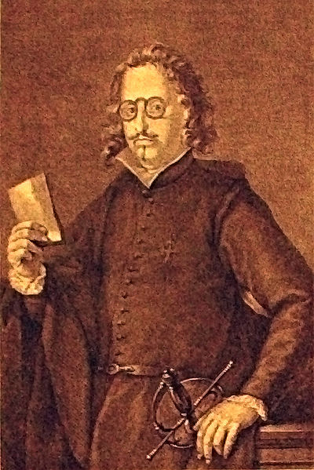

Swashbuckler 1700
- Dread Pyrate
- Member

- 1,115 posts
- Gender:Male
- Location:Europe
- Interests:pyrates, pryvateers, naval military and other history, different books, good movies, music (a little bit), drawing, games,...
Posted April 8, 2012 (edited) · Report post
interesting stuff from from Johnson's book:
" I had an Account given me of one of these merry Tryals, and as it appeared diverting, I shall give the Readers a short Account of it.
The Court and Criminals being both appointed, as also Council to plead, the Judge got up in a Tree, and had a dirty Taurpaulin hung over his Shoulders; this was done by Way of Robe, with a Thrum Cap on his Head, and a large Pair of Spectacles upon his Nose: Thus equipp'd, he settled himself in his Place, and abundance of Officers attending him below, with Crows, Handspikes, &c. instead of Wands, Tipstaves, and such like. "
that will make me think were glasses so expensive...
This is picture from late 17th century: man selling glasses

Edited April 8, 2012 by Swashbuckler 1700

Dirigoboy
- Bilge Rat
- 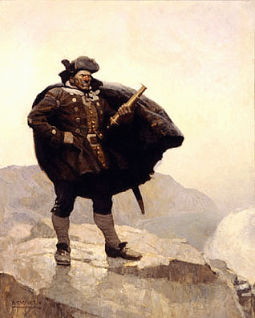
- Member

- 17 posts
- Gender:Male
- Location:Norumbega, just shy of the Maritimes
- Interests:history, militaria collecting, background artist for historical film, the sea, wooden ships, living history, watering a new interest in the pirate era.
Posted April 9, 2012 · Report post
Located in Waterville, Maine, you could always peruse the wares of Ed Welch's Antique Vintage Eyeglasses. He carries original 18th century specs. You could email him with your wants here; information@eyeglasseswarehouse.com

Mission
- Goat Specialist
- Admin

- 5,081 posts
- Gender:Male
- Location:Monroe, MI
- Interests:Scholarly piracy, designing and creating haunted house rooms and props, movies, abstract thinking, abstruse thinking, obstructive thinking, ideating, random thinking, movies, cartoons, movies, movies scores, cycling, world peace and small furry dogs, movies, writing, drawing, personal skills training, gremlins and, of course, lest I forget, movies.
Posted April 10, 2012 · Report post
These posts are from the thread "But I stole 'em from a...", starting with this post. I was going to comment on them there, but I think it makes more sense to answer it here.
On 3/9/2006 at 4:07 PM, Dorian Lasseter said:
Er.... ain't them blue tinted glasses s'posed ta be a treatment fer Syphalis?
On 3/9/2006 at 4:32 PM, Dorian Lasseter said:
I do believe so... as I believe it causes sensitivity to light...
Know anyone who does 18th C. Physician?
I have never seen proof for any such thing for GAoP thus far. (If I do, I will be sure to post it.) I did find something about a commanders and knights wearing green tints for sun glasses in Malta (and no where else yet); the original quote for that can be found here. Of course, I am reading medical texts and this may well be an individual response. Still, you would think with all the various texts on syphilis/lues venerea that someone would have mentioned this if it were common.
Keep in mind that we haven't conclusively proven there were glasses with arms around during period at this point. The only thing suggesting there were any glasses with arms was that bit I pulled from Elisabeth Bennion's book and I can't back it up.

William Brand
- Mercury Malefactor
- Admin

- 8,884 posts
- Gender:Male
- Location:Logan, Utah
- Interests:My name is William Pace and I live and work as a graphic designer, illustrator and photographer in Northern Utah. I'm married to the lovely Tracy Pace and we have three children. In addition to all things art, I enjoy traveling and meeting new people from every walk of life. I've always been a fan of history, theology, and of course, Pyracy.
http://www.youtube.com/watch?v=PSkt-q-HihQ
Posted April 23, 2012 · Report post
I just found another eyeglass provider. Sorry if it was mentioned before now.
http://www.reenactors-shop.de/product_info.php?info=p2157_Medieval-Spectacle-Frame.html
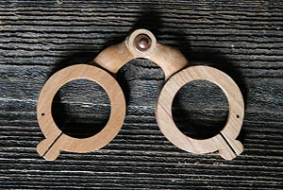
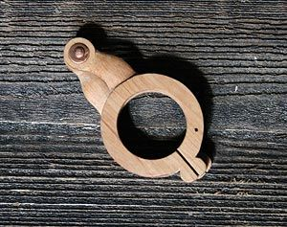

Grymm
- First Mate
- Member

- 281 posts
- Gender:Male
- Location:Chilterns UK
- Interests:Stuff
Posted April 23, 2012 (edited) · Report post
http://www.bikkelenbeen.com/nl/producten/Categorie/Brilmonturen+I/Veerbril+blond+hoorn/?artikelnummer=011&pagina=1
Makers of horn spec frames, technically they's muddyevil but.......

Edited April 23, 2012 by Grymm

Capt. Sterling
- Sticky Fingers Sterling Needs a New Hat
- Member

- 10,302 posts
- Gender:Pyrate Hunter
- Location:here
- Interests:Killing pirates, haven't met one yet worth keeping alive....
Posted April 24, 2012 · Report post
On 4/10/2012 at 3:47 PM, Mission said:
On 3/9/2006 at 4:07 PM, Dorian Lasseter said:
Er.... ain't them blue tinted glasses s'posed ta be a treatment fer Syphalis?
Quote
I have never seen proof for any such thing for GAoP thus far. (If I do, I will be sure to post it.) I did find something about a commanders and knights wearing green tints for sun glasses in Malta (and no where else yet); the original quote for that can be found here. Of course, I am reading medical texts and this may well be an individual response. Still, you would think with all the various texts on syphilis/lues venerea that someone would have mentioned this if it were common.
Hmmm the idea of blue tinted lenses as a treatment for STDs seems to have been something that comes up during the Victorian era... IF I had more time I could get ye some info from a grand debate on another board that took place several years back...but... any how, fwiw didn't have anything from our time frame posted there....

Capt. Sterling
- Sticky Fingers Sterling Needs a New Hat
- Member

- 10,302 posts
- Gender:Pyrate Hunter
- Location:here
- Interests:Killing pirates, haven't met one yet worth keeping alive....
Posted June 7, 2012 · Report post
Hope this isn't a double posting, but found this and wanted to get it down before I lost it...at work so time is limited...
"A brief aside - The Wormleighton Evidence
However, latest research by the BOA Museum suggests that sides may have existed before the traditionally accepted date...indeed possibly as early as the 1680s.
It all depends on how you interpret a figurative sculpture of a man wearing spectacles (apparently with sides!) from the carved oak screen now to be found at St Peter's Church, Wormleighton, on the Warwickshire/Oxfordshire border.
The earliest parts of the church date from 1150 but when staff of the BOA Museum first paid attention to this carving back in the 1950s the screen was thought to have been taken from the Spencer Mansion in the village of Wormleighton, built in the reign of Henry VIII (1509-1547) which would make it early 16th century, some two hundred years before sides were believed to have been invented. It seemed an unlikely scenario. For various reasons we now think that the screen was originally in Southam Parish Church but was removed for safe-keeping during the Civil War. After the war the screen was included for a short period in the decorative scheme of the Star Chamber in the Manor House. We think that the be-spectacled man is a later addition to this screen, added circa 1685 when the screen was reassembled at Wormleighton Church and reduced in size. This seems much more credible and would still make it the earliest representation of spectacle sides.
The 'sides' appear to pass at a rigid right angle from the lugs of the spectacle front. Unfortunately their terminals are concealed by the flowing locks of hair. We may never be sure if this is what we think it might be. The carving's Tudor-style hat is probably a red herring. One assumes that the artist had added spectacles with sides anachronistically, but the possibility of folk memory playing some part cannot be dismissed altogether. At least the available evidence entitles us to suggest, cautiously, that the first development of spectacle sides is possibly English and possibly from the last quarter of the seventeenth century."
Found here: http://www.college-optometrists.org/en/knowledge-centre/museyeum/online_exhibitions/spectacles/side.cfm
Scroll down to see the photos, sorry no time to transfer them here yet...

landlubbersanonymous
- Plunderer
- Member

- 354 posts
- Gender:Not Telling
- Location:California, USA
- Interests:History, arts, collecting, reenacting
Posted June 15, 2012 · Report post
On 6/7/2012 at 9:28 AM, Capt. Sterling said:
Hope this isn't a double posting, but found this and wanted to get it down before I lost it...at work so time is limited...
Found here: http://www.college-o...tacles/side.cfm
Scroll down to see the photos, sorry no time to transfer them here yet...
Thanks Capt. Good timing too. We were just having some dialog about this.

Swashbuckler 1700
- Dread Pyrate
- Member

- 1,115 posts
- Gender:Male
- Location:Europe
- Interests:pyrates, pryvateers, naval military and other history, different books, good movies, music (a little bit), drawing, games,...
Posted January 31, 2013 · Report post
Well
I found this picture by accident some time ago there we have early glasses with some sort of frames or laces:
Luis de Velasco II, Marqués de Salinas, circa 1607

Mission
- Goat Specialist
- Admin

- 5,081 posts
- Gender:Male
- Location:Monroe, MI
- Interests:Scholarly piracy, designing and creating haunted house rooms and props, movies, abstract thinking, abstruse thinking, obstructive thinking, ideating, random thinking, movies, cartoons, movies, movies scores, cycling, world peace and small furry dogs, movies, writing, drawing, personal skills training, gremlins and, of course, lest I forget, movies.
Posted January 31, 2013 · Report post
There's something very post-actual-painting-looking about those frames...
Although here's another, very similar one (possibly the same one with the removal of the arm and book) of Luis de Velasco y Castilla wearing the same general design, so I'm probably wrong. That downward loop on the ear-piece is very curious looking. It's just about the same in both images, too.

Mission
- Goat Specialist
- Admin

- 5,081 posts
- Gender:Male
- Location:Monroe, MI
- Interests:Scholarly piracy, designing and creating haunted house rooms and props, movies, abstract thinking, abstruse thinking, obstructive thinking, ideating, random thinking, movies, cartoons, movies, movies scores, cycling, world peace and small furry dogs, movies, writing, drawing, personal skills training, gremlins and, of course, lest I forget, movies.
Posted September 3, 2013 · Report post
On 9/13/2011 at 8:38 AM, Mission said:
On 5/11/2009 at 10:05 AM, Mission said:
I found this in Elizabeth Bennion's, Antique Medical Instruments:
This suggests that eyeglasses with some way to attach them to the wearer's head existed in 1700. (Quick, someone over there go check the British Optical Ass'n Library for verification.) I do wish we knew the dates of each of those.
Also, according to Bennion, eye glasses and pince nez glasses were very popular and common and could be fairly cheaply purchased.
My link to the above photo got broken somehow, so I fixed it. Image 359, with sidepieces is dated to 1700 like Grymm's pair. So unless both sources are wrong, they clearly existed at that time.
Well I got to talking with someone who wears glasses about this and he was all curious to know if Bennion's book was accurate. So I sent an email to the British Optical Association Library asking about it. Here is the response:
Quote
Bennion's book is well known for being error-strewn, although for its day it was a decent attempt to draw together knowledge on a little-covered topic and many of her mistakes have only been identified as a result of subsequent research. She is not correct on this point.
The precise date for the introduction of sides has not been established. A guide date of 1727 is usually offered. There is some possibility that an illustration purporting to show sides may date from as early as 1715 but that is not proven and, in any case, we can be certain that sides did not gain widespread popularity before the 1740s and it remained common to wear the earlier form of nose spectacles until at least 1800.
An article of mine on spectacles for re-enactors will appear shortly in an issue of Seaxe magazine: http://www.seaxe.eu/index.html
Yours sincerely
Neil Handley, MA, AMA+, FRSA
Curator, British Optical Association Museum
The College of Optometrists
42 Craven Street
London WC2N 5NG
So based on the most current knowledge, no earpieces (sides) during the GAoP.

Mission
- Goat Specialist
- Admin

- 5,081 posts
- Gender:Male
- Location:Monroe, MI
- Interests:Scholarly piracy, designing and creating haunted house rooms and props, movies, abstract thinking, abstruse thinking, obstructive thinking, ideating, random thinking, movies, cartoons, movies, movies scores, cycling, world peace and small furry dogs, movies, writing, drawing, personal skills training, gremlins and, of course, lest I forget, movies.
Posted September 3, 2013 · Report post
I thanked Mr. Handley, and he added some more info for us in his response:
Quote
I should add that the image reproduced from Bennion’s book was an original 1932 catalogue photograph from the BOA Museum and in this instance the author was only repeating an error made by my 1930s predecessor at a time when scholarship on the subject was far less developed. I would now date that particular pair (previously numbered 359, but surviving in our collection as item LDBOA1999.986) to the period 1800-1820. The previous date attribution was very wrong indeed.
Incidentally the latest discovery on spectacle sides, which I am about to publish, has provided evidence that the contemporary name for such devices was ‘temple spectacles’ and that in the 1740s they cost 14 shillings each (with a case). I should point out also that these early temple spectacles were also designed to be worn with a powdered wig...the padded terminals are for insertion within the folds of the wig and do not interact in any way with the ears, which were covered.

jendobyns
- Pyrate Captain
- Member

- 562 posts
- Gender:Female
- Location:Baltimore
- Interests:too numerous to mention, really. Period foodways, baroque dance, material culture, etc., etc.
Posted September 3, 2013 · Report post
Ah, well that makes sense. You wouldn't want to wear anything that would snag on the wig.

Daniel
- Pyrate Captain
- Member

- 652 posts
- Gender:Male
- Location:McLean, VA
- Interests:History, pirates, fiction, writing, writing historical fiction about pirates, jokes, games, law.
Posted September 4, 2013 · Report post
Chardin painted two self-portraits showing himself with glasses - one with sides, and one without!
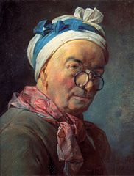
Chardin, Self-Portrait, 1771.
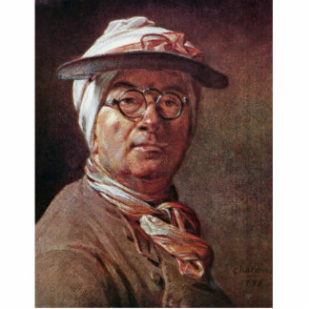
Chardin, Self-Portrait, 1775.

Mission
- Goat Specialist
- Admin

- 5,081 posts
- Gender:Male
- Location:Monroe, MI
- Interests:Scholarly piracy, designing and creating haunted house rooms and props, movies, abstract thinking, abstruse thinking, obstructive thinking, ideating, random thinking, movies, cartoons, movies, movies scores, cycling, world peace and small furry dogs, movies, writing, drawing, personal skills training, gremlins and, of course, lest I forget, movies.
Posted November 19, 2013 · Report post
On 4/10/2012 at 3:47 PM, Mission said:
These posts are from the thread "But I stole 'em from a...", starting with this post. I was going to comment on them there, but I think it makes more sense to answer it here.
On 3/9/2006 at 4:07 PM, 'Dorian Lasseter said:
Er.... ain't them blue tinted glasses s'posed ta be a treatment fer Syphalis?
On 3/9/2006 at 4:32 PM, 'Dorian Lasseter said:
I do believe so... as I believe it causes sensitivity to light...
Know anyone who does 18th C. Physician?
I have never seen proof for any such thing for GAoP thus far. (If I do, I will be sure to post it.)
The Chirurgion's Apprentice wrote an article on tinted glasses that basically says the same thing as I have: there is no connection between syphilis and wearing of colored lenses from period. (Nor did she find any evidence of syphilitic patients having eyes sensitive to the light.) It makes me wonder where this one got started...

Mission
- Goat Specialist
- Admin

- 5,081 posts
- Gender:Male
- Location:Monroe, MI
- Interests:Scholarly piracy, designing and creating haunted house rooms and props, movies, abstract thinking, abstruse thinking, obstructive thinking, ideating, random thinking, movies, cartoons, movies, movies scores, cycling, world peace and small furry dogs, movies, writing, drawing, personal skills training, gremlins and, of course, lest I forget, movies.
Posted February 17, 2014 · Report post
We were talking about tinted eyeglasses on Facebook and I came across some interesting info on the availability and pricing of glasses during period. So I thought I'd share it here for future reference.
On their page Eyeglasses Through the Ages, AntiqueSpectacles.com says,
"By the end of the 15th century, spectacle peddlers who were selling glasses was a common sight on the streets of Western Europe. People often rummaged through baskets filled with German metal and leather spectacles in an effort to improve their vision. The purchaser tried on several pair and finally selected the one of his preference. This demand increased exponentially after 1665, when the first newspaper, the London Gazette, appeared."
Dr. Glyn Walsh explains in his article "Spectacles Through the Ages and Period Inaccuracies" on optometry.co.uk:
"Spectacles have never really been a luxury item in the past 350 years, although the price of the cheaper types possibly rose a little in real terms in the 18th and 19th centuries... By the end of the 17th century, the price of imports had fallen to 3s 4d (wholesale) for “a number of boxes of spectacles”, each apparently containing more than a dozen pairs of (possibly German) spectacles – perhaps 1d a pair retail." (Glyn, p. 33)
This doesn't speak to the price of colored lenses, of course. Samuel Pepys comment in his diary when he purchased a pair was "I did buy me a pair of green spectacles, to see whether they will help my eyes." (Pepys, Dec. 24, 1666) It doesn't really tell us much about the cost, but it's so offhanded that I can't believe they were outrageously expensive. It seems doubtful he would have purchased something really expensive without first knowing if they would work.
Glyn's article is directed at reenactors and contains some interesting info.

